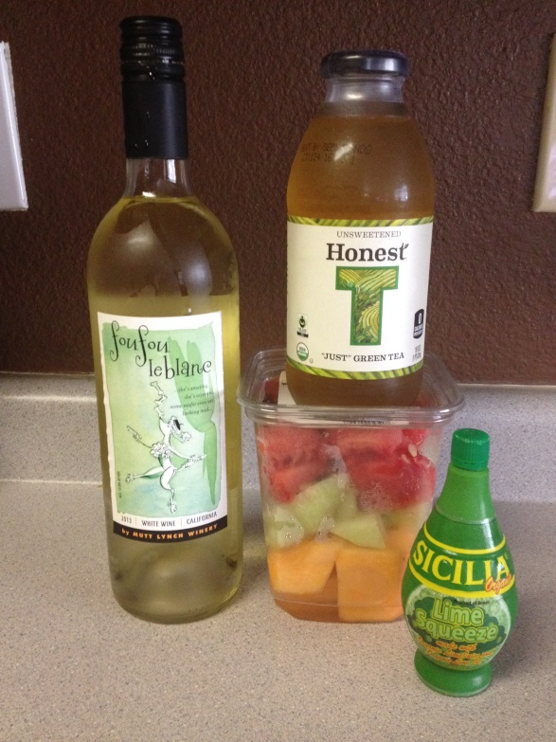
Green Tea Sangria
1 bottle Mutt Lynch Winery Fou Fou le Blanc White
1 bottle unsweetened green tea or 1 ½ cups fresh brewed green tea chilled
½ cup white sugar or 3 tablespoons simple syrup
½ cup lime juice or 3 tablespoons lime concentrate
Mixed melon slices
Before adding fruit, stir ingredients until sugar dissolves. Add melon & chill… Enjoy! (Better Homes & Gardens)
